897 East Iron Avenue
Dover, Ohio 44622

TUSCARAWAS COUNTY GENERAL HEALTH DISTRICT
Phone (330) 343- 5555
Fax (330) 343-1601
Email director@tchdnow.org
Web site www.tchdnow.org
Patient Navigator Policy

Effective April 8, 2019
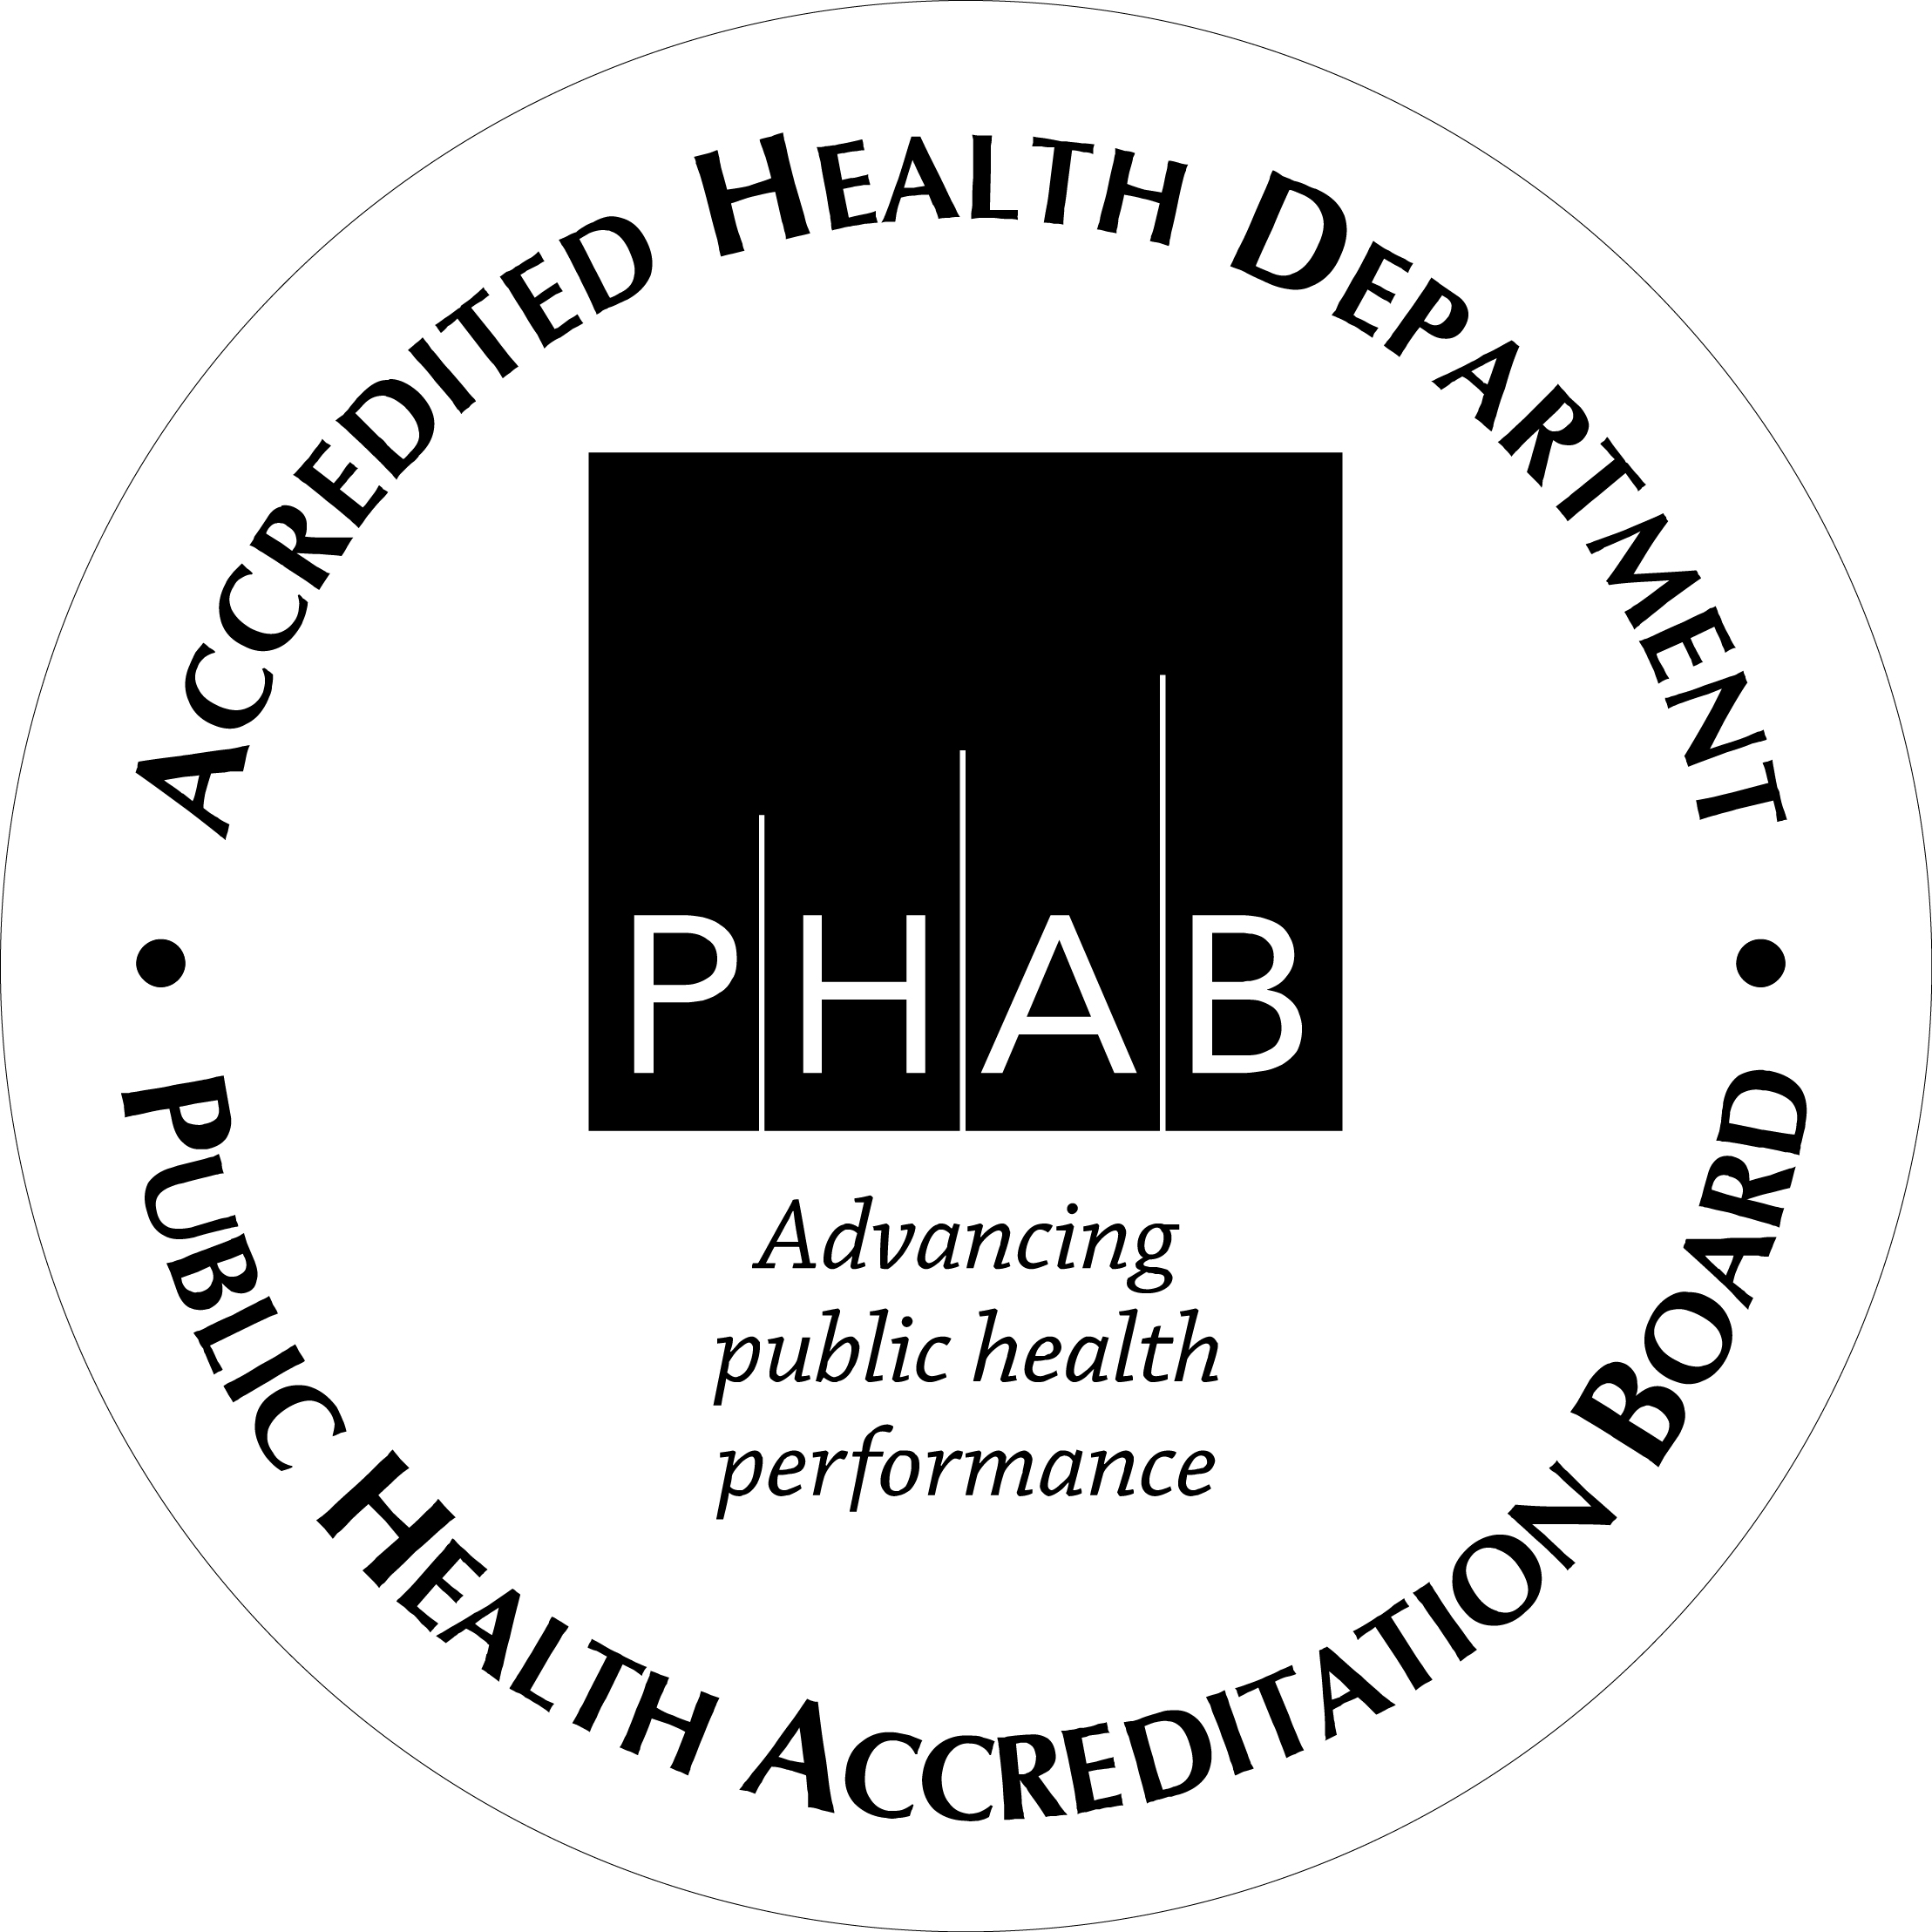

It is the policy of the Tuscarawas County Health Department that all persons without medical insurance meet with the patient navigator to determine Medicaid eligibility or to learn about Marketplace options. This required meeting should take place on the same date of service. Once the patient meets with the navigator a pop up should be placed on the patients chart as to the outcome of the meeting, date of meeting and the income at the time of the meeting. The patient should be required to meet with the navigator anytime the patient’s income changes. The only exemption to this are persons who declare “no contact” under the Reproductive Health and Wellness program.

The medical records department or any person who schedules a patient who states they have no insurance should notify the patient of the new requirement to meet with the navigator. The navigator should then be notified of the persons name and date and time of appointment so that they may plan to meet with patient accordingly.

Registration should notify the navigator when the patient arrives for an appointment.

