897 East Iron Avenue
Dover, Ohio 44622

TUSCARAWAS COUNTY GENERAL HEALTH DISTRICT
Phone (330) 343- 5555
Fax (330) 343-1601
Email director@tchdnow.org
Web site www.tchdnow.org
Tuscarawas County Health Department
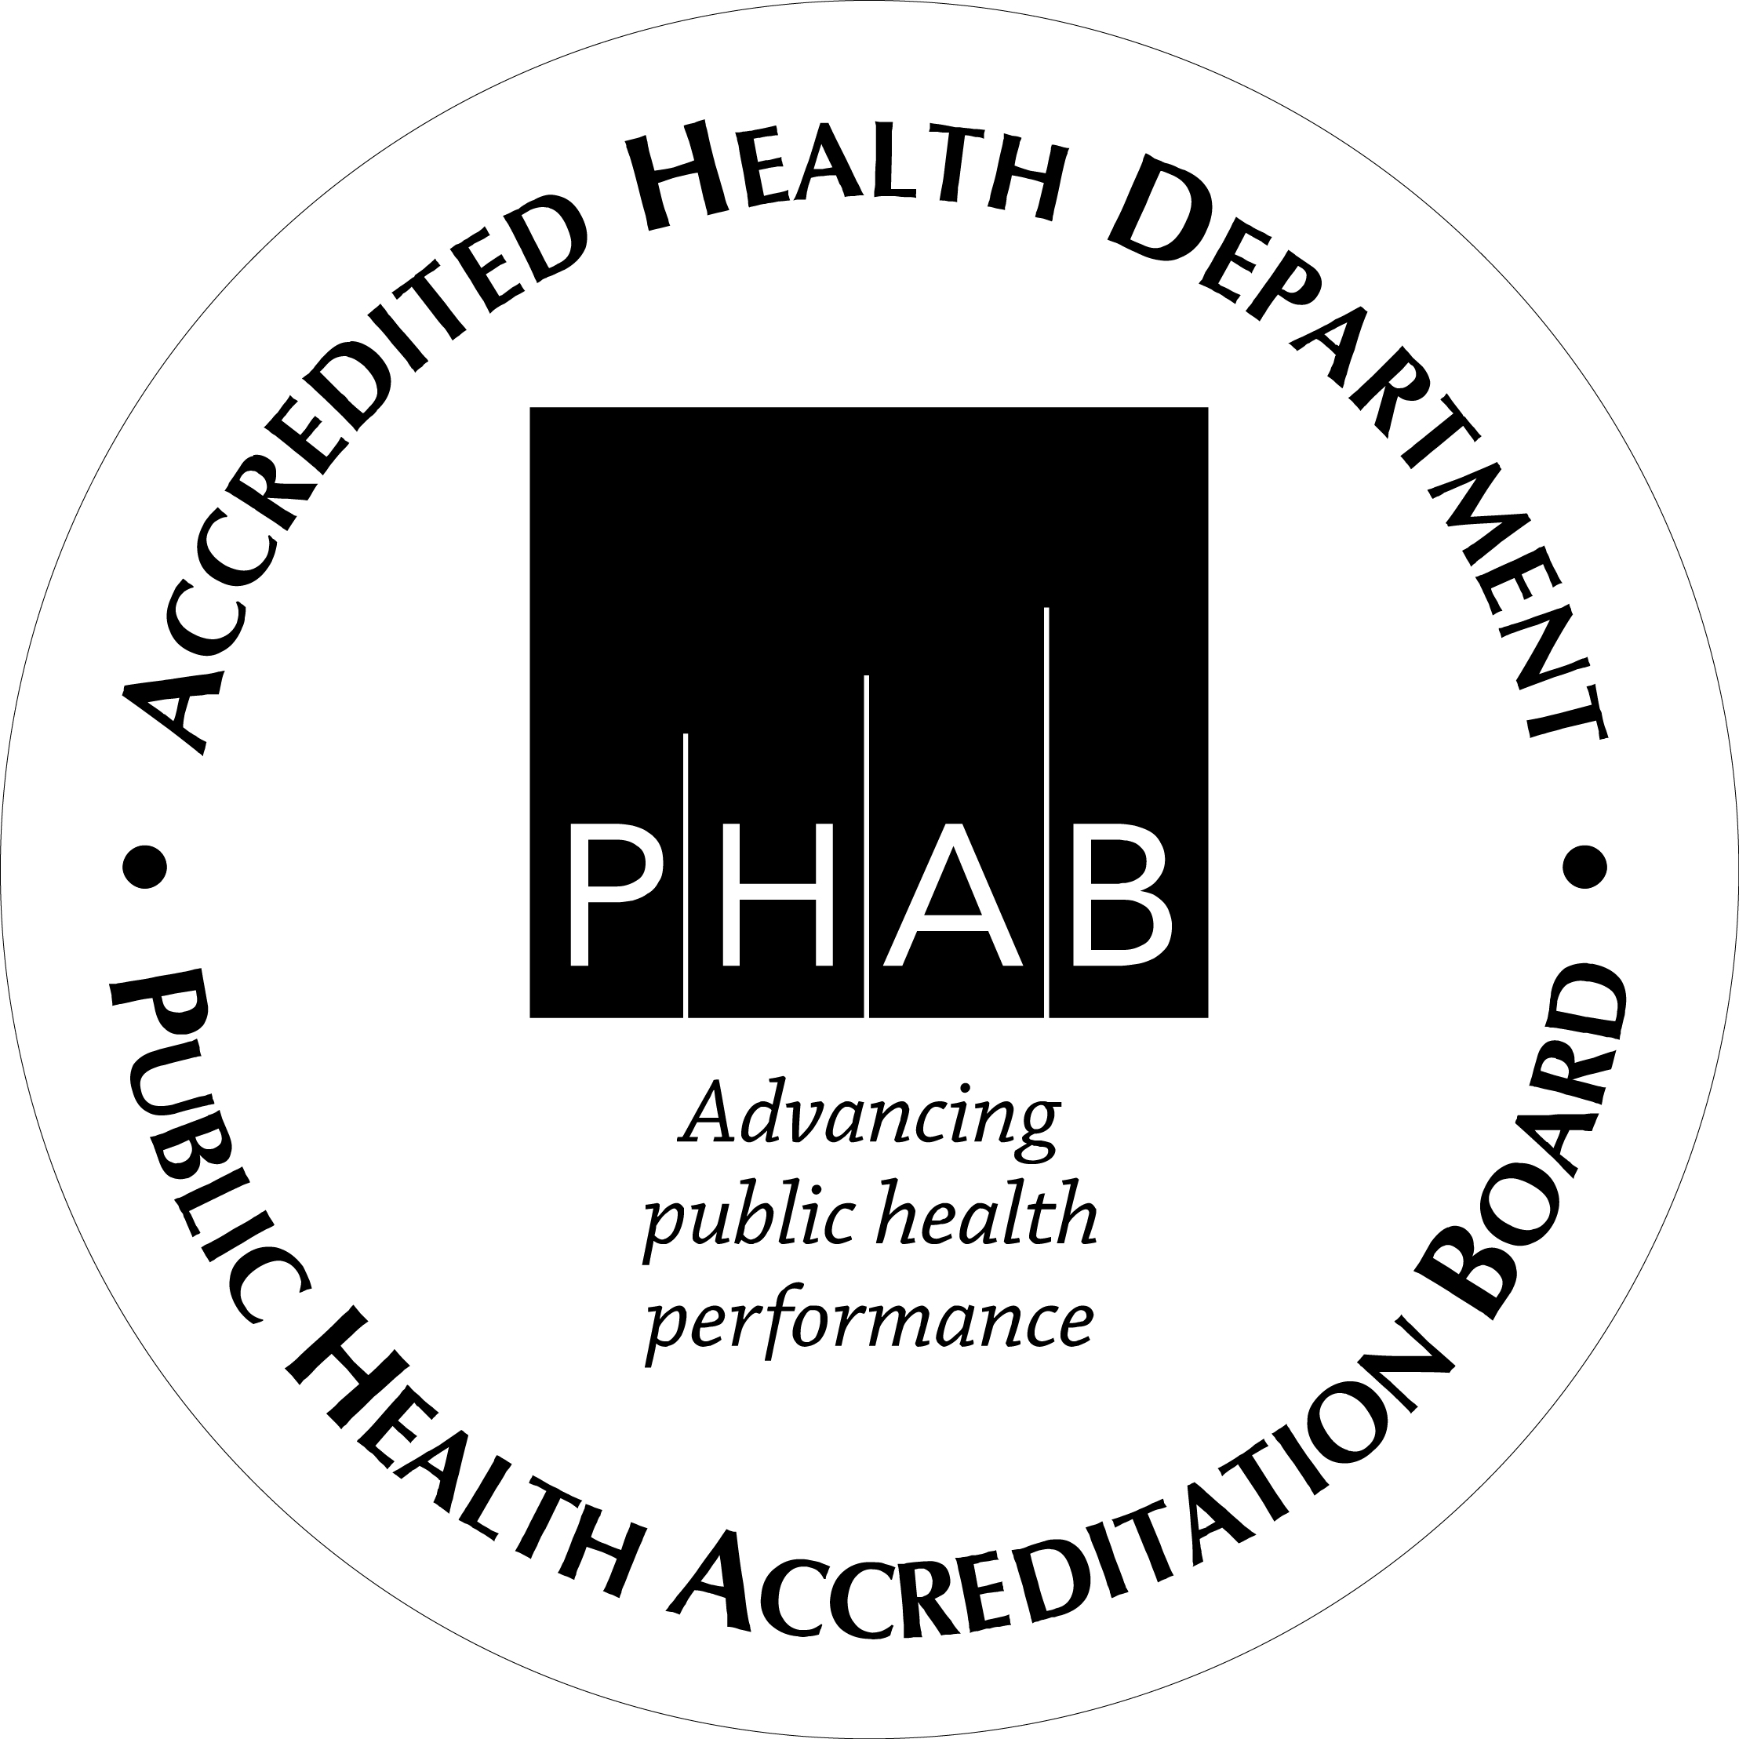
Child Fatality Board Case Review 2019

Background Information
Ohio Revised Code 307.621 mandates each of Ohio’s counties to review the deaths of children under the age of 18

Ohio Revised Code 307.626 mandates by the first day of April of each year, the person convening the child fatality review board shall prepare and submit to the Ohio department of health a report that summarizes the following information with respect to the child deaths that were reviewed by the review board in the previous calendar year:(1) The cause of death;(2) Factors contributing to death;(3) Age;(4) Sex;5) Race;(6) The geographic location of death;(7) The year of death.
The report shall specify the number of child deaths that were not reviewed during the previous calendar year.
The report may include recommendations for actions that might prevent other deaths, as well as any other information the review board determines should be included.
(B) Reports prepared under division (A) of this section shall be considered public records under section 149.43 of the Revised Code.
(C) The child fatality review board shall submit individual data with respect to each child death review into the Ohio department of health child death review database or the national child death review database. The individual data shall include the information specified in division (A) of this section and any other information the board considers relevant to the review. Individual data related to a child death review that is contained in the Ohio department of health child death review database is not a public record under section 149.43 of the Revised Code.

All meetings are confidential and not subject to “sunshine laws”. Additionally, violation of confidentiality is a second-degree misdemeanor.

2019 Meeting Notes

On February 21, 2019 The Tuscarawas County Health Department’s Child Fatality Board met in the large conference room at the Tuscarawas County Health Department to review fourteen child fatalities from 2018.

Attendees:
Katie Seward, Tuscarawas County Health Commissioner
Andrea Dominick, Director of Alcohol and Addiction, Director of Grants and Health Education
Amy Kaser, Director of Nursing
Jeffery Cameron, MD, County Coroner
Cathy Clark, Coroner’s Office
Angie Frantz, Sanitarian in training
Mandy Porsser, Child Protective Supervisor, TCJFS
Natalie Bollon, Executive Director, ADAMHS Board
Vicki Ionna, New Philadelphia City Health Commissioner
Jeff M., Detective, LT. Tuscarawas County Sheriff Department
Nicole Dorsey, TCHD Health Education
Kelly Snyder, TCHD Health Education

The board reviewed the circumstances surrounding each death, discussed prior health issues of the child, prenatal care of the mother (if applicable), and if the death could have been potentially prevented.

The board also discussed educational messages the community may benefit from in order to prevent further child fatalities. Educational messages included:
- Ensuring vaccinations are up to date for children who are immunocompromised
- Breast Feeding Education
- The dangers of driving under the influence of drugs and/or alcohol
- The dangers of driving without a seatbelt
- Education and outreach on disease prevention to Tuscarawas County’s Hispanic population, especially on the topic of Tuberculosis
- Status asthmaticus, uncontrolled Asthma signs and symptoms

The Health Education Department along with administration will establish messaging to be presented via social media, written materials, etc. throughout the year.

The next meeting will be held during the first quarter of 2020.

